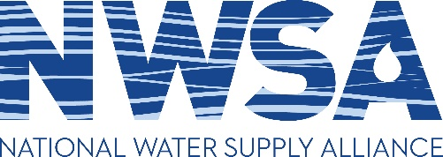

DC Roundtable/Business Meeting
Doubletree Crystal City
Salon C/D/E (North Tower)
Wednesday, April 1, 2020

Draft Agenda

8:00 a.m. Coffee, pastries

8:30 a.m. Welcome and Introductions

President’s Report
Communications Committee Update
Membership Committee Update
WRDA and Infrastructure proposals Update
Guest presentation
Overview of afternoon session with USACE

11:30 a.m. Lunch on your own

1:30 p.m. USACE presentation on National portfolio of reallocations

2:00 p.m. MG Spellmon remarks on Water Supply status and priority issues

2:30 p.m. Open discussion with USACE Water Supply Team on priority issues

4:30 p.m. Adjourn

