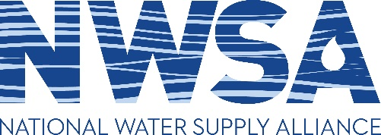

Annual Meeting 2022
Radisson Bismarck
605 E. Broadway Avenue, Bismarck, ND
August 22-24, 2022

DRAFT Agenda

Monday, August 22

9:00 a.m. Welcome, Continental breakfast

9:15 a.m. Opening Remarks

9:45 a.m. Update from USACE Leadership

10:15 a.m. North Dakota Water Supply Overview

Perspectives from the Upper Missouri River Basin

11:15 a.m. NWSA Member Presentations

12:15 p.m. NWSA Luncheon

Radisson Hotel

1:30 p.m. Guest presentation

2:00 p.m. Water Supply Development

2:45 p.m. USACE Water Supply Team

Introduce new team members, PCX priorities

3:15 p.m. Break

3:30 p.m. Current and Emerging Issues for Water Supply Storage at USACE Reservoirs
(Study on Water Supply as a Mission, Surplus water pricing)

4:30 p.m. Open discussion/Member issues

6:30 p.m. Dinner (TBD)

Tuesday, August 23

9:00 a.m. Welcome, Continental breakfast

9:15 a.m. NWSA Business Meeting - Governmental Relations

9:45 a.m. NWSA Business Meeting – President’s Session

10:15 a.m. NWSA Business Meeting -- Policy Committee

11:15 a.m. NWSA Business Meeting – Membership Committee

11:30 a.m. NWSA Business Meeting – Regular Order of Business

- Nominations and elections for Board seats
- Treasurer’s Report

12:00 p.m. Adjourn

Wednesday, August 24

8:30 a.m. Tour of Garrison Dam and Water Supply Facilities
Sponsored by Houston Engineering

General schedule:
8:30 a.m. Bus departs from Radisson Hotel
10:00 a.m. Tour of Garrison Dam and Power Plant
12:00 p.m. Box lunches at lakeside park
1:00 p.m. Bus departs for Snake Creek pumping plant
?? Additional stop
5:00 p.m. Bus arrives at Radisson Hotel

