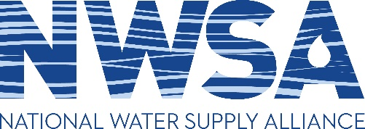

2020 Annual Meeting (virtual)
October 29-30, 2020

Agenda
(as of 10/26/2020)

EASTERN TIME ZONE

Thursday, October 29, 2020

2:00 p.m. Welcome/Introductions
Darren Gore, NWSA President

- Review agenda for next two days
- President’s progress report and vision for 2021

2:30 p.m. Update from the U.S. Army Corps of Engineers
Mr. Al Lee, SES
Director of Civil Works
U.S. Army Corps of Engineers

3:00 p.m. Discussion of Water Supply Priorities and Policies
USACE Water Supply team and Attendees

4:30 p.m. Adjourn

Friday, October 30, 2020

12:00 p.m. Unlocking historic data to understand the effect of changing conditions on Corps of Engineers reservoirs
Dr. Lauren Patterson, Duke University

USACE Water Supply Business Line Technical Work
Brad Hudgens, USACE Institute for Water Resources

EASTERN TIME ZONE

1:00 p.m. NWSA Business Meeting – Policy

State Primacy and Storage Accounting: How States Can Solidify their Water Allocation Authority
Lewis Jones, King & Spalding
John Fortuna, King & Spalding

Member discussion on planning and strategy for WRDA
John Anderson and Geoff Bowman, Van Scoyoc Associates

2:15 p.m. NWSA Business Meeting – Regular order of business

- Nominations and election for 3 Board seats
- Treasurer’s report
- Communications report
- Governmental Relations report

3:00 p.m. Adjourn

